SMART FASHION RECOMMENDATION

APPLICATION

|  |  |
| --- | --- |
| **Assignment Number** | **4** |
| **Assignment Date** | **28th October 2022** |
| **Student Name** | **SANTHOSH.R** |
| **Student Roll Number** | **510919106015** |
| **Maximum marks** | **2 MARKS** |

**Question:**

1. **Pull an Image from docker hub and run it in docker playground.**
2. **Create a dockerfile for the job portal / flask application and deploy it in Docker desktop application.**
3. **Create an IBM container registry and push a docker image of a flask application or job portal app.**
4. **Create a Kubernetes cluster in IBM cloud and deploy flask application image or job portal image and also expose the same app to run in nodeport.**

**Answers:**

* 1. **Pull an Image from docker hub and run it in docker playground.**

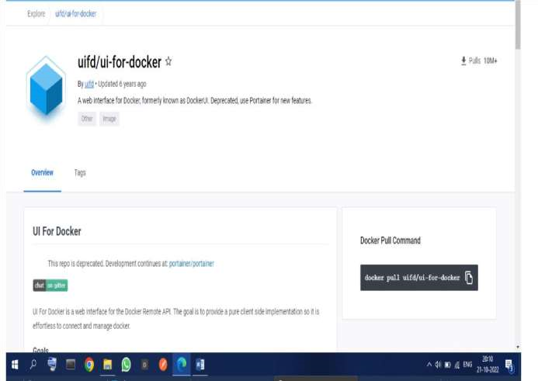

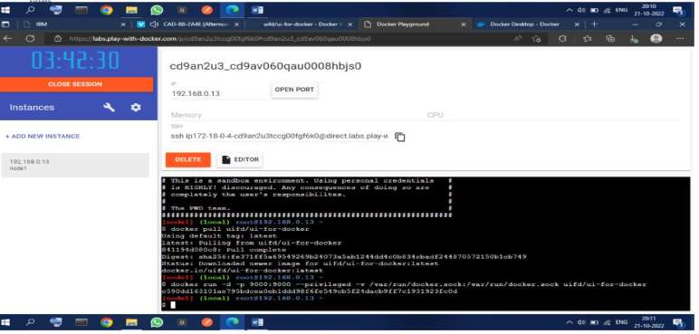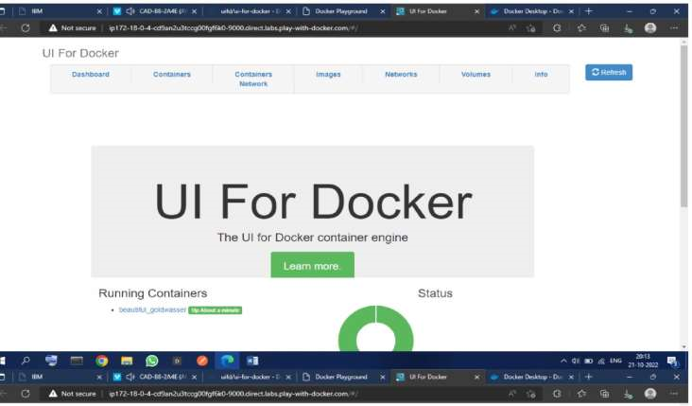

* 1. 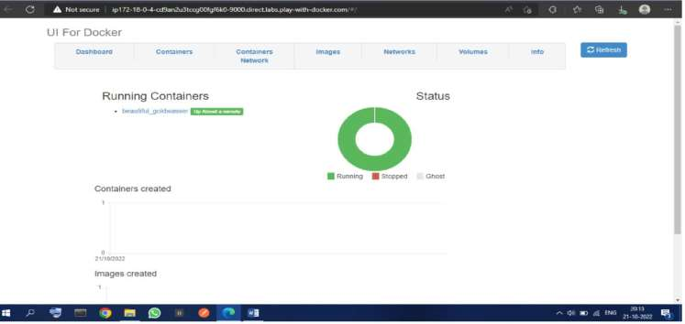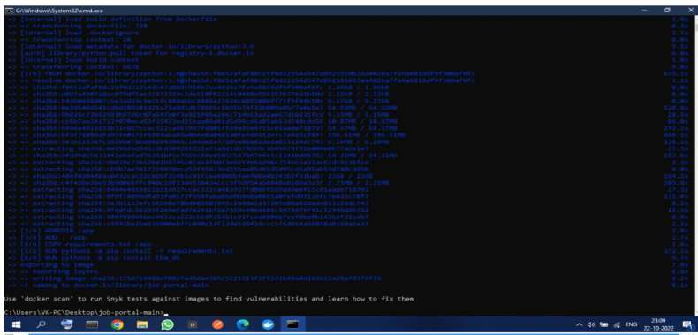**Create a dockerfile for the job portal / flask application and deploy it in**

**Docker desktop application.**

* 1. 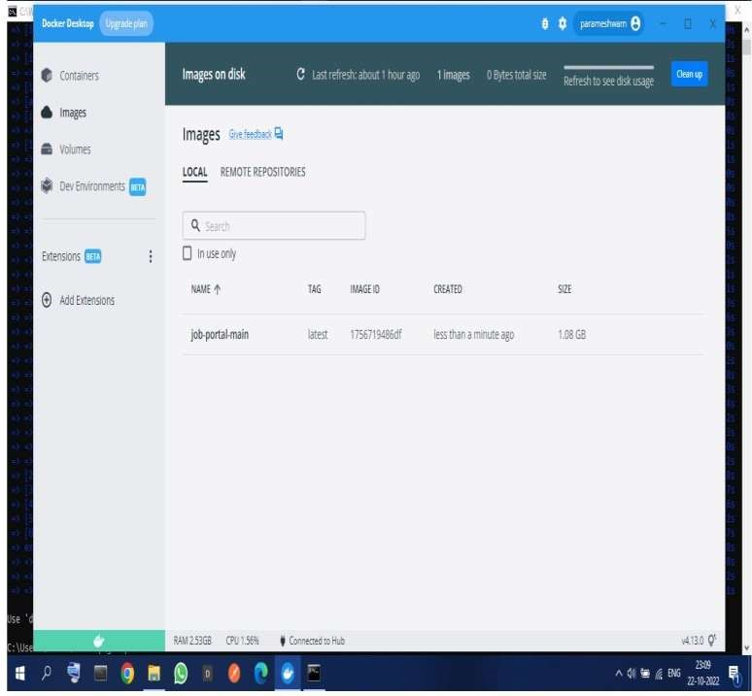**Create an IBM container registry and push a docker image of a flask application or job portal app.**

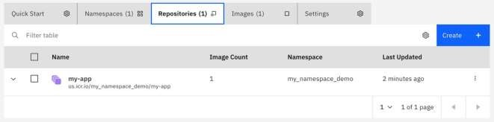

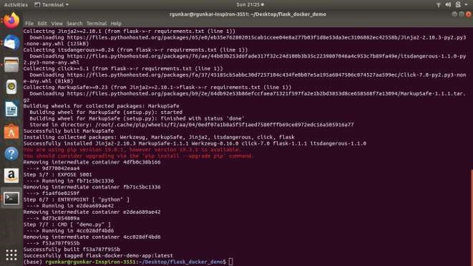

|  |
| --- |
| **2. Change directory to Lab 1:** |
| **cd "Lab 1"**  **3. Log in to the IBM Cloud CLI:**  **ibmcloud login**  **To specify an IBM Cloud region, include the API endpoint.** |

|  |
| --- |
| **Note: If you have a federated ID, use  ibmcloud login --sso  to log in to the IBM**   **Cloud CLI. You know you have a federated ID when the login fails without the** |
| **-- sso  and succeeds with the -- sso  option.** |
| **4. In order to upload images to the IBM Cloud Container Registry, you first need to create a namespace with the following command:** |
| **ibmcloud cr namespace-add <my_namespace>**  **5. Build the container image with a  1  tag and push the image to the IBM Cloud** |
| **Registry:**   **ibmcloud cr build --tag us.icr.io/<my_namespace>/hello-world:1 .** |
| 1. **Verify the image is built:**   **ibmcloud cr images**   1. **If you created your cluster at the beginning of this, make sure it's ready for use.** |

**4.**

**Create a Kubernetes cluster in IBM cloud and deploy flask application image or job portal image and also expose the same app to run in nodeport.**

|  |
| --- |
| **1 . Push an image to IBM Cloud Container**  **Registry**  **To push an image, we first must have an image to push. We have prepared several** |
| **Dockerfile s in this repository that will create the images. We will be running the**   **images, and creating new ones, in the later labs.** |
| **This lab uses the Container Registry built in to IBM Cloud, but the image can be**   **created and uploaded to any standard Docker registry to which your cluster has acces** |

* + 1. **Run  ibmcloud ks clusters  and make sure that your cluster is in "Normal" state.**
    2. **Use ibmcloud ks workers --cluster <yourclustername> , and make sure that all workers are in "Normal" state with "Ready" status.**
    3. **Make a note of the public IP of the worker.**

**You are now ready to use Kubernetes to deploy the hello-world application.**

# . Deploy your application

**1. Run ibmcloud ks cluster config --cluster <yourclustername> .**

**Start by running your image as a deployment:**

**kubectl create deployment hello-world-deployment**

**-- image=us.icr.io/<my_namespace>/hello-world:1**

**When you're all done, you can either use this deployment in the** [**next lab of this**  **course**](https://github.com/IBM-EPBL/IBM-Project-5901-1658819637/blob/main/Snekha/Lab%202/README.md) **, or you can remove the deployment and thus stop taking the course.**

**1. To remove the deployment and service, use  kubectl delete all -l**   **app=hello-world-deployment .**

**This action will take a bit of time. To check the status of your deployment, you can use**

**kubectl get pods .**

**You should see output similar to the following:**

**=> kubectl get pods**

**NAME READY STATUS RESTARTS AGE helloworld-562211614-0g2kd 0/1 ContainerCreating 0 1m**

|  |
| --- |
| **2. Once the status reads  Running , expose that deployment as a service,**  **accessed through the IP of the worker nodes. The example for this course listens on port**  **8080 . Run:** |
| **kubectl expose deployment/hello-world-deployment --type=NodePort --port=8080**  **-- name=hello-world-service --target-port=8080** |
| **3. To find the port used on that worker node, examine your new service:** |
| **kubectl describe service hello-world-service**   **Take note of the "NodePort:" line as < nodeport>** |
| **4. Run ibmcloud ks worker ls --cluster <name-of-cluster> , and note the public IP as < public-IP> .** |
| **5. You can now access your container/service using  curl <public-**  **IP>:<nodeport>** |
| **( or your favorite web browser). If you see, "Hello world! Your app is up and** |
| **running in a cluster!" you're done!** |